8.76: Just after the collision: 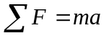
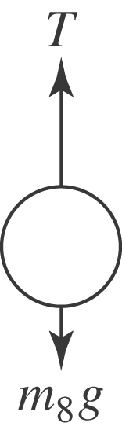
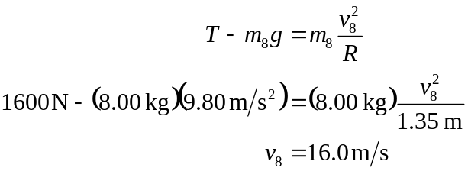

Energy and momentum are conserved during the elastic collision.

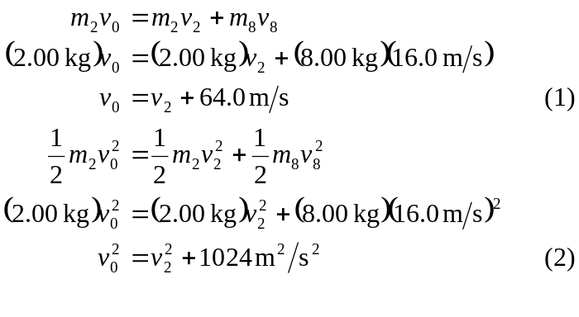
Solve (1) and (2) for 